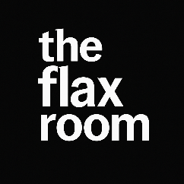

“eat and dream”

Breakfast Brunch

The Flax Fry *Bacon Sausage Egg Breads* £9.5 Soup & Toastie £7.5

Pancake Stack *Bacon Eggs Syrup* £8.5 Quiche & Leaves £9.5

French Toast *Sweet or Savory* £7.5 Chicken Caesar £9.5

Breakfast Buttie *Sausage Egg & Cheese* £8.5 Salt & Chilli Chix £9.5

Lunch

Burger Bucannon Dexter Beef, Flax Relish £15

**For More Flax**

**Sweet & Savoury Treats**

**Please Visit Our Counter**

Fish, Tartre, Lemon, Peas if you want them. £16

Pasta, Spicey Chicken £13.5

Goujons, Salad & Dip £12.5

Sandwiches

Sambos made to order *if we have it, you can have it. £6.5

Kids £6.50 Sides £3.50 Extras £1.50

Pork Sausages Just Plain Chippies Dips

Fish Supper Garlic Chippies Bits

Chicken Bites Curried Chippies Sauces

Pasta N’ Sauce The Daily Salad Odds & Ends

We will cater to your needs as best we can, please inform a team member of any dietary or special requirements. Our products may contain allergens.

The Flax Menu is designed with gluten free in mind. Most of our dishes are, or can be tailored accordingly.